**UNIT-3**

**Java Applet**

A Java application that is integrated into a webpage is called an applet. It functions as a front-end and is run within the web computer. It makes a page more interactive and dynamic by operating inside the web browser. Applets are hosted on web servers and inserted into HTML pages via the OBJECT or APPLET tags. Applet is a special type of program that is embedded in the webpage to generate the dynamic content. It runs inside the browser and works at client side.

It can be compared to a tiny application that runs on the address bar. In addition to updating content in real-time and responding to human input, it may also play basic puzzles or graphics.

**Advantage of Applet**

There are many advantages of applet. They are as follows:

* It works at client side so less response time.
* Secured
* It can be executed by browsers running under many plateforms, including Linux, Windows, Mac Os etc.

**Drawback of Applet**

* Plugin is required at client browser to execute applet.

**TYPES OF AN APPLET**

1. **Local Applet**
2. **Remote Applet**

## Local Applet

**Local Applet** is written on our own, and then we will embed it into web pages. Local Applet is developed locally and stored in the local system. A web page doesn't need the get the information from the internet when it finds the local Applet in the system. It is specified or defined by the file name or pathname. There are two attributes used in defining an applet, i.e., the **codebase** that specifies the path name and **code** that defined the name of the file that contains Applet's code.

**Remote Applet**

A remote applet is designed and developed by another developer. It is located or available on a remote computer that is connected to the internet. In order to run the applet stored in the remote computer, our system is connected to the internet then we can download run it. In order to locate and load a remote applet, we must know the applet's address on the web that is referred to as Uniform Recourse Locator(URL).

**Applet Life Cycle in Java**

In Java, an [applet](https://www.javatpoint.com/java-applet) is a special type of program embedded in the web page to generate dynamic content. Applet is a class in Java.

The applet life cycle can be defined as the process of how the object is created, started, stopped, and destroyed during the entire execution of its application.

**java.applet.Applet class:**

For creating any applet java.applet.Applet class must be inherited. It provides 4 life cycle methods of applet.

1. **public void init():** is used to initialized the Applet. It is invoked only once.
2. **public void start():** is invoked after the init() method or browser is maximized. It is used to start the Applet.
3. **public void stop():** is used to stop the Applet. It is invoked when Applet is stop or browser is minimized.
4. **public void destroy():** is used to destroy the Applet. It is invoked only once.

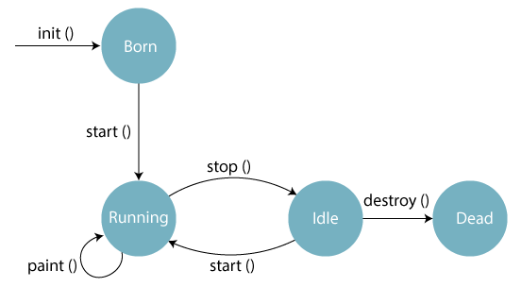

There are five methods of an applet life cycle, and they are:

* **init():** The init() method is the first method to run that initializes the applet. It can be invoked only once at the time of initialization. The web browser creates the initialized objects, i.e., the web browser (after checking the security settings) runs the init() method within the applet.
* **start():** The start() method contains the actual code of the applet and starts the applet. It is invoked immediately after the init() method is invoked. Every time the browser is loaded or refreshed, the start() method is invoked. It is also invoked whenever the applet is maximized, restored, or moving from one tab to another in the browser. It is in an inactive state until the init() method is invoked.
* **stop():** The stop() method stops the execution of the applet. The stop () method is invoked whenever the applet is stopped, minimized, or moving from one tab to another in the browser, the stop() method is invoked. When we go back to that page, the start() method is invoked again.
* **destroy():** The destroy() method destroys the applet after its work is done. It is invoked when the applet window is closed or when the tab containing the webpage is closed. It removes the applet object from memory and is executed only once. We cannot start the applet once it is destroyed.
* **paint():** The paint() method belongs to the Graphics class in Java. It is used to draw shapes like circle, square, trapezium, etc., in the applet. It is executed after the start() method and when the browser or applet windows are resized.